Aim : Basic commands of linux and hadoop

# Commands for Linux

1. sudo : Used to perform tasks that requires root permissions.
2. pwd : It shows the present working directory.
3. cd : It is use to come back in the root directory.
4. ls : It list down all the directories and folders present.
5. cat : Displays the content of the file.
6. 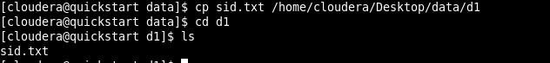cp : Copy one file from current directory to another directory.
7. 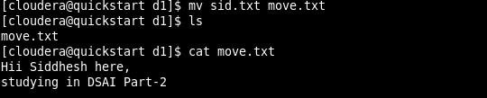mv : Used to move and rename files and directories.
8. 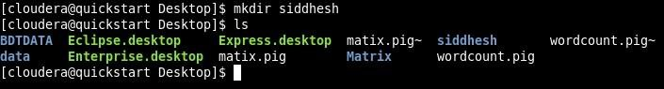mkdir : Creates a new directory.
9. rmdir : Deletes the directory.

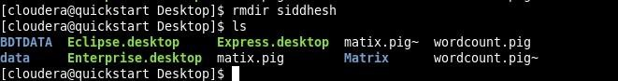

1. rm : Removes/ Deletes the file from a directory.
2. 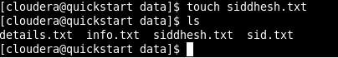touch : Creates an empty file.
3. 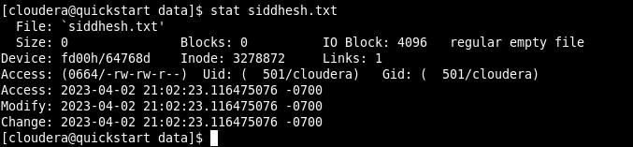stat : Detail view of the file.
4. vi : Creates and open the file.

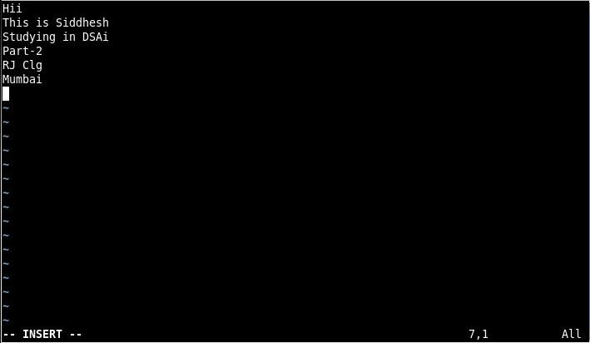

1. 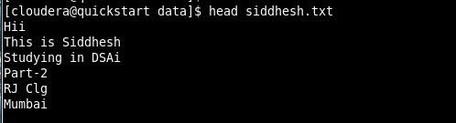head : Displays the first 10 lines of a text file.
2. tail : Displays the last 10 lines of a text file.

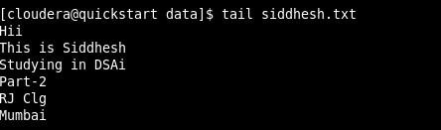

# Commands for Hadoop

1. hadoop version : Gives the version of the hadoop.

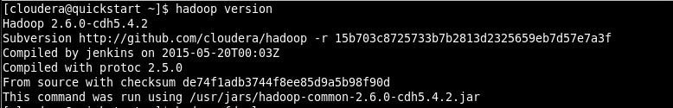

1. 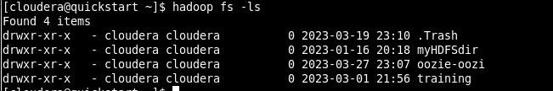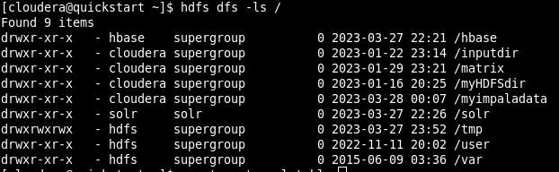ls : List down all the files in hadoop.
2. 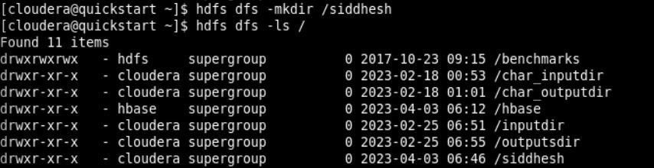mkdir : Create a directory.
3. touchz : Creates a new file.
4. put : Copy files/folders from local file system to HDFS.
5. cat : Prints the file contents.

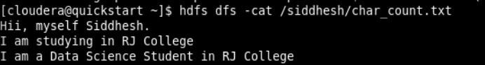

1. 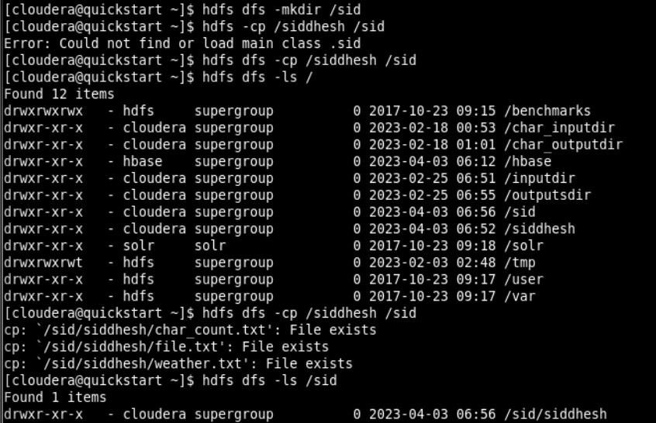cp : Use to copy files within HDFS
2. rm : Deletes a file from the HDFS.

